Flowchart for Adoptions Section 38 of the Highways Act 1980

PLANNING PHASE
Length of phase depends on complexity of application

DESIGN PHASE
Length of phase is scheme specific

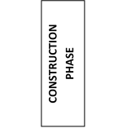
ADOPTION
COMPLETED

